According to Biblemapper 3.0, Maon was a city ~0.9 miles south of Carmel in southern Judah, ~8.2 miles south of Hebron, ~10.2 miles south of Mamre, ~20.8 miles south of Bathlehem, ~25.7 miles south of Jerusalem, ~20.7 miles northeast of Beersheba.

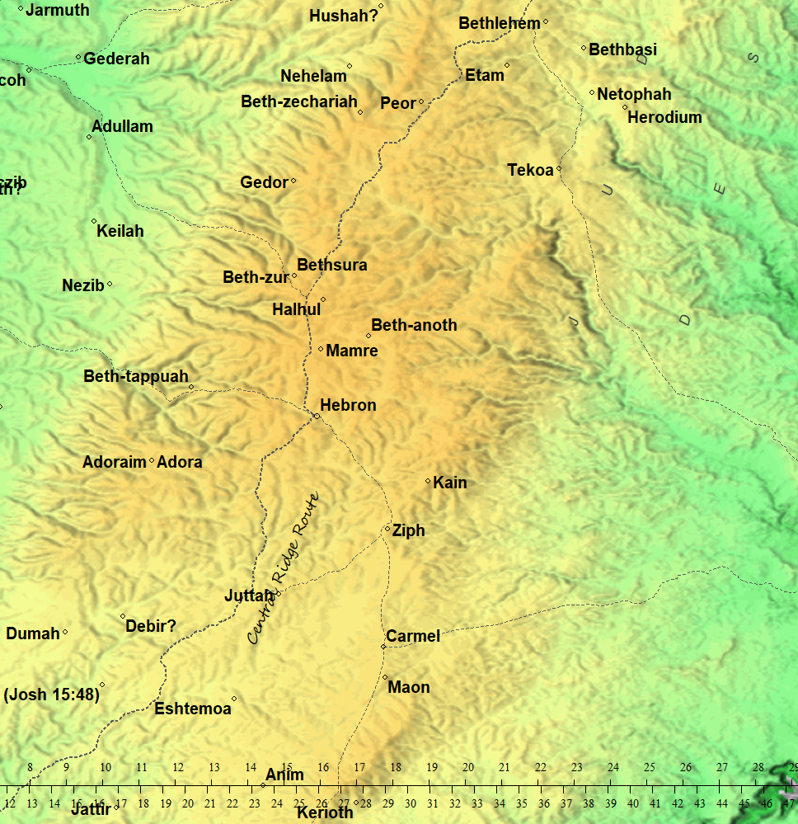

Jos 15:55 | ⁵⁵ Maon^{H4584}, Carmel, and Ziph, and Juttah, | A city in the mountains of the inheritance of Judah
Jdg 10:12 | The Zidonians also, and the Amalekites, and the Maonites^{H4584}, did oppress you; and ye cried to me, and I delivered you out of their hand. | Roughly 18 years after the judge Jair dies, the LORD refers to past oppressors that He delivered the children of Israel from
1Sa 23:24,25 | ²⁴ And they arose, and went to Ziph before Saul: but David and his men were in the wilderness of Maon^{H4584}, in the plain on the south of Jeshimon.  ²⁵ Saul also and his men went to seek him. And they told David: wherefore he came down into a rock, and abode in the wilderness of Maon^{H4584}. And when Saul heard that, he pursued after David in the wilderness of Maon^{H4584}. | After David saves Keilah, the Ziphites tell Saul that David is hiding in the hill of Hachilah but David is in the wilderness of Maon
1Sa 25:2 | And there was a man in Maon^{H4584}, whose possessions were in Carmel; and the man was very great, and he had three thousand sheep, and a thousand goats: and he was shearing his sheep in Carmel. | Nabal (Abigail’s husband; the future wife of David) was from Maon and is referred to as a “son/man of Belial” that cannot be reasoned with.
1Ch 2:45 | And the son of Shammai was Maon^{H4584}: and Maon^{H4584} was the father of Bethzur. | Maon is listed as a descendant of Judah son of Jacob/Israel.
H4584
מָעֹון (Mâʻôwn | maw-ohn')
Derivation: the same as מָעֹון (H4583); a residence;
Strong's: Maon, the name of an Israelite and of a place in Palestine
KJV: Maon, Maonites. Compare בֵּית בַּעַל מְעֹון, מְעוּנִי (H1010, H4586)
Typo: lemma מְעוּנָי third vowel, corrected to מְעוּנִי

Ezra 2:1,50
² Now these are the children of the province that went up out of the captivity, of those which had been carried away, whom Nebuchadnezzar the king of Babylon had carried away unto Babylon, and came again unto Jerusalem and Judah, every one unto his city;
⁵⁰ The children of Asnah, the children of Mehunim^{H4586}, the children of Nephusim,
H4586
מְעוּנִי (Mᵉʻûwnîy | meh-oo-nee')
Typo: lemma מְעוּנָי third vowel, corrected to מְעוּנִי
Derivation: or מְעִינִי; probably patrial from מָעֹון (H4584);
Strong's: a Meunite, or inhabitant of Maon (only in plural)
KJV: Mehunim(-s), Meunim.

